COT MINISTRIES WEBSITE

Website link = https://cotministries.unaux.com/
Website admin = https://cotministries.unaux.com/wp-login.php?redirect_to=https%3A%2F%2Fcotministries.unaux.com%2Fwp-admin%2Foptions-general.php&reauth=1
Word Press = User Name = shaveesh
= password = shaveesh123
cloudfare = shaveesh@123
zerossl=Shaveesh@123
email id = faithfulfellowship8@gmail.com
password = shaveesh123
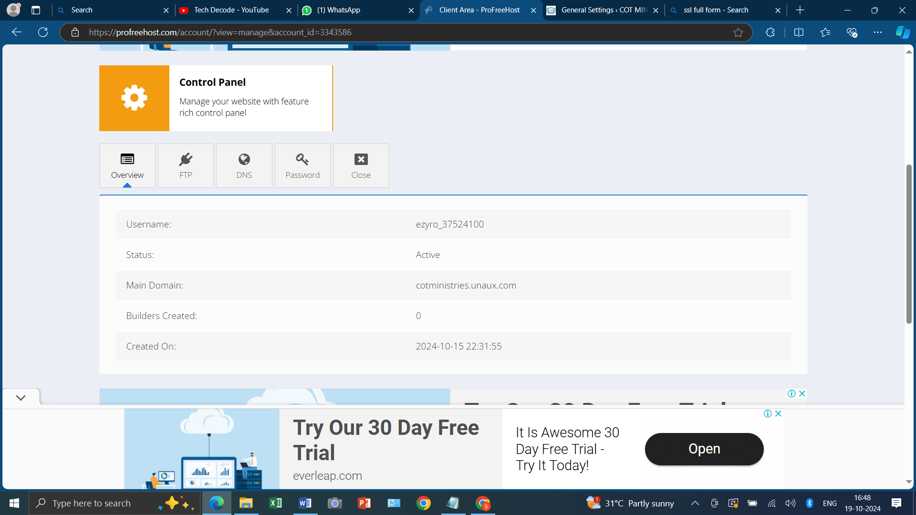
Pro fee host = https://profreehost.com/account/?view=manage&account_id=3343586
FTP =
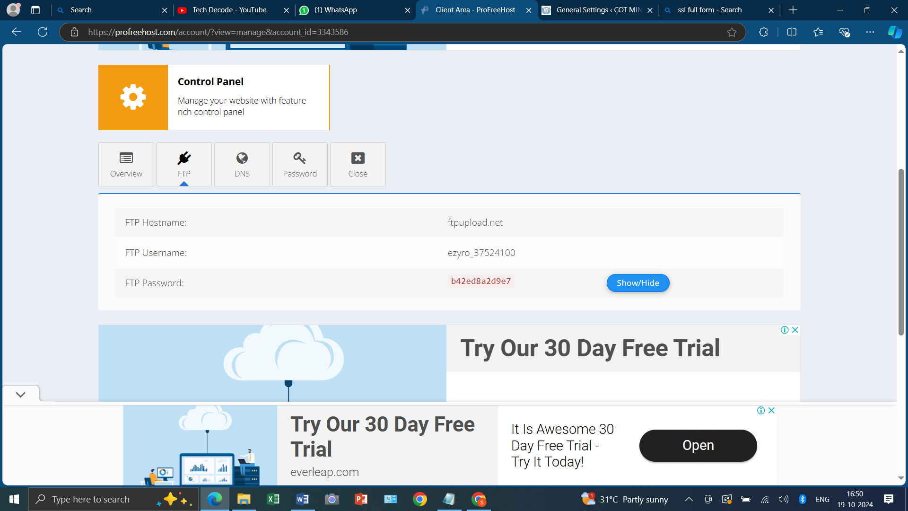
DNS =
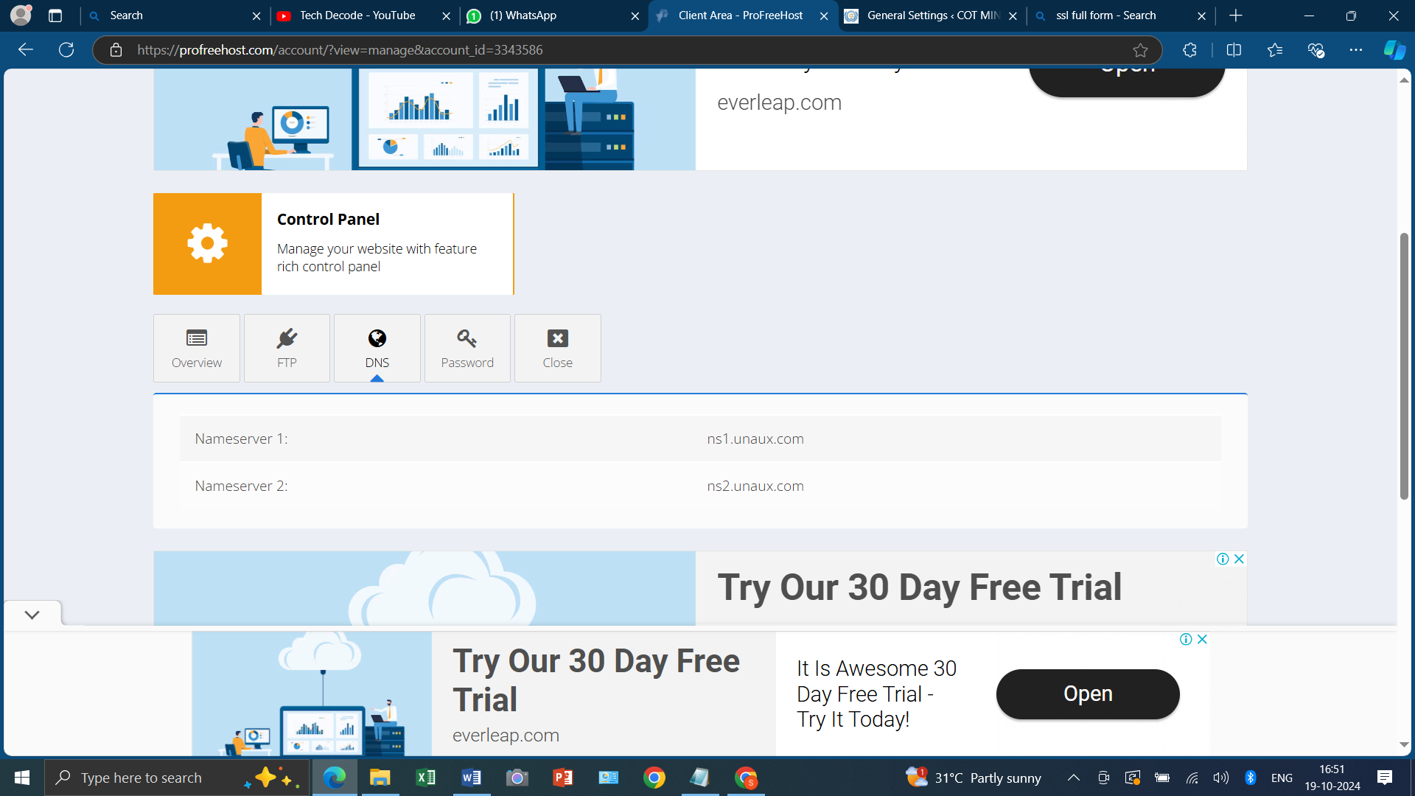
Password =
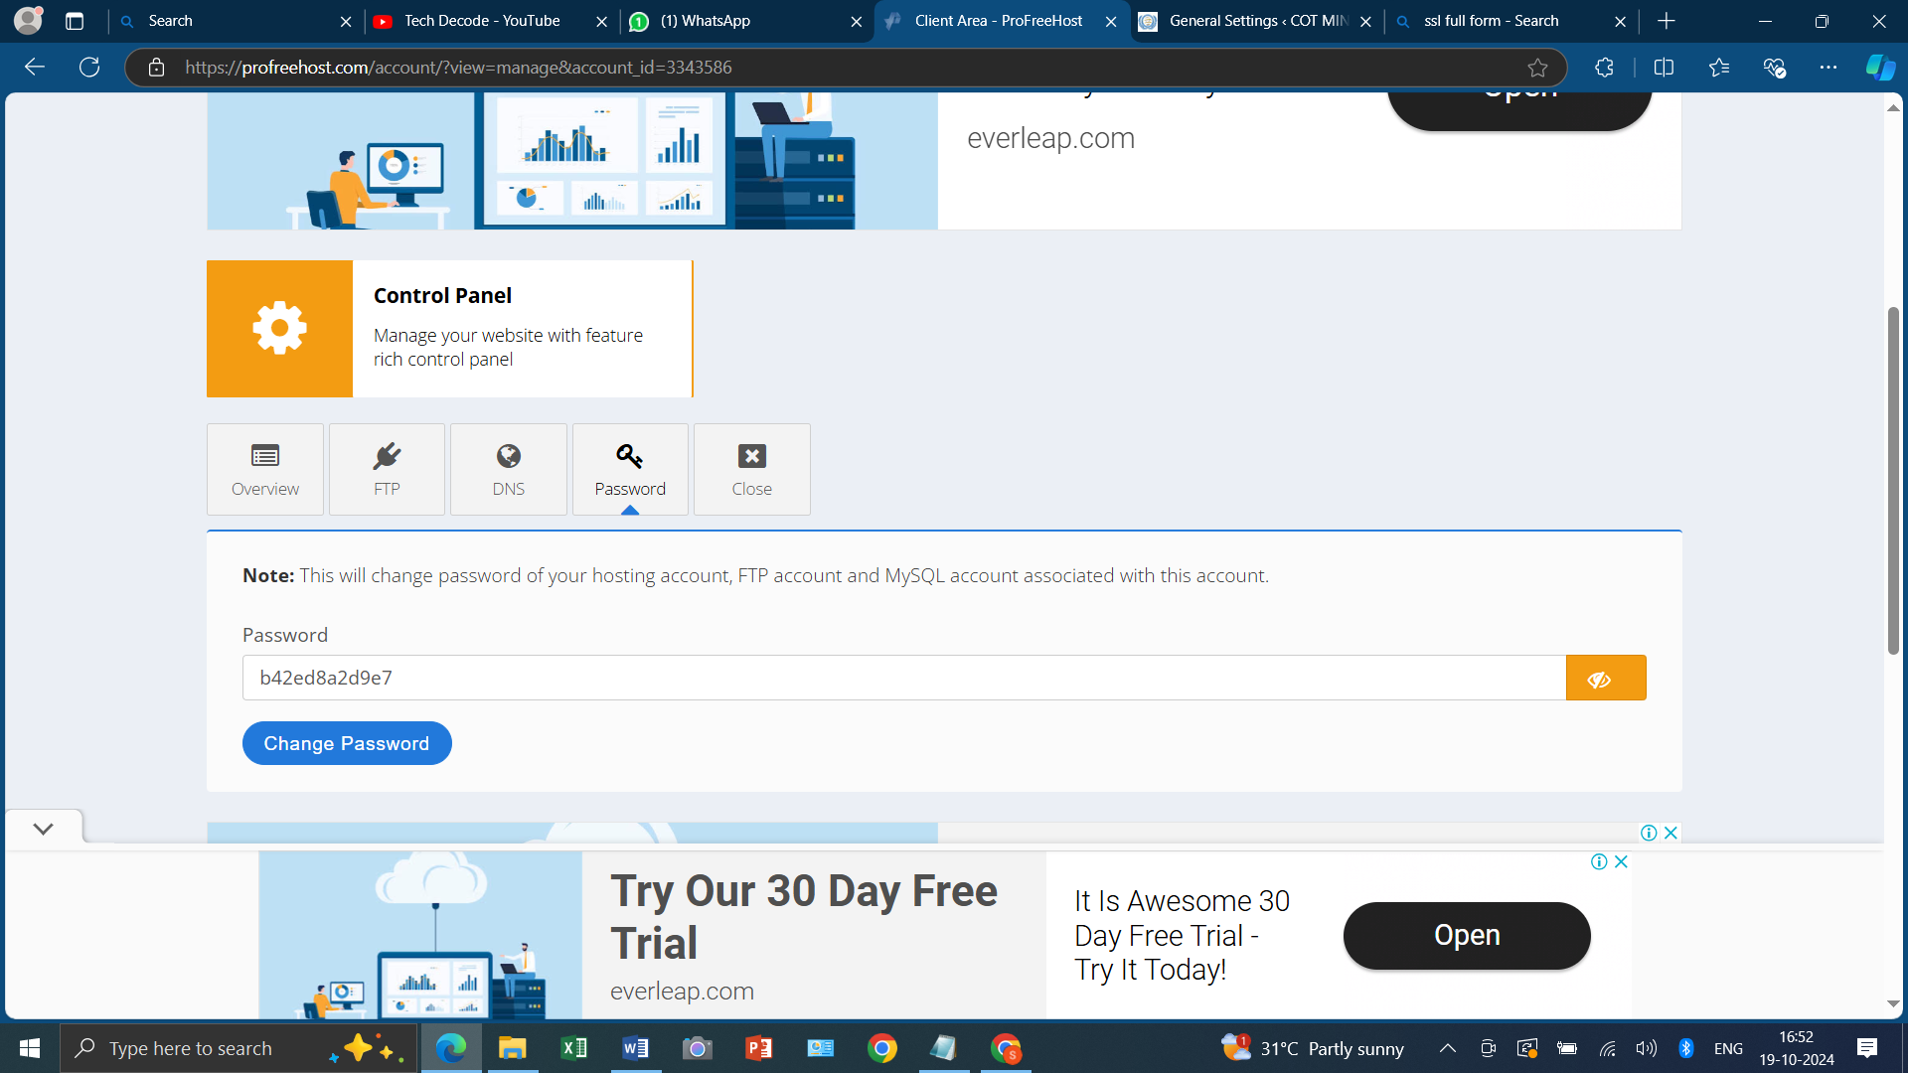
Control panel = https://cpanel.ezyro.com/panel/indexpl.php?id=7a013fe30f432b090d3fb977d6956e6343712685
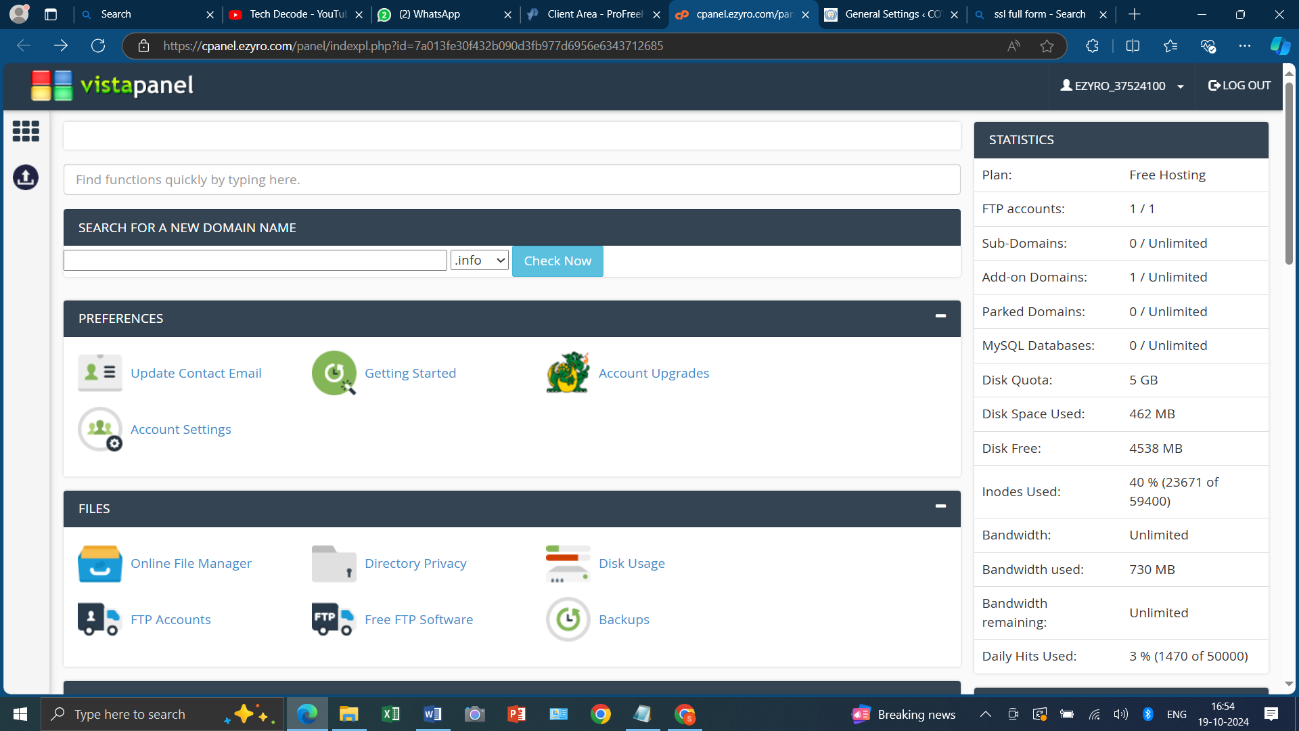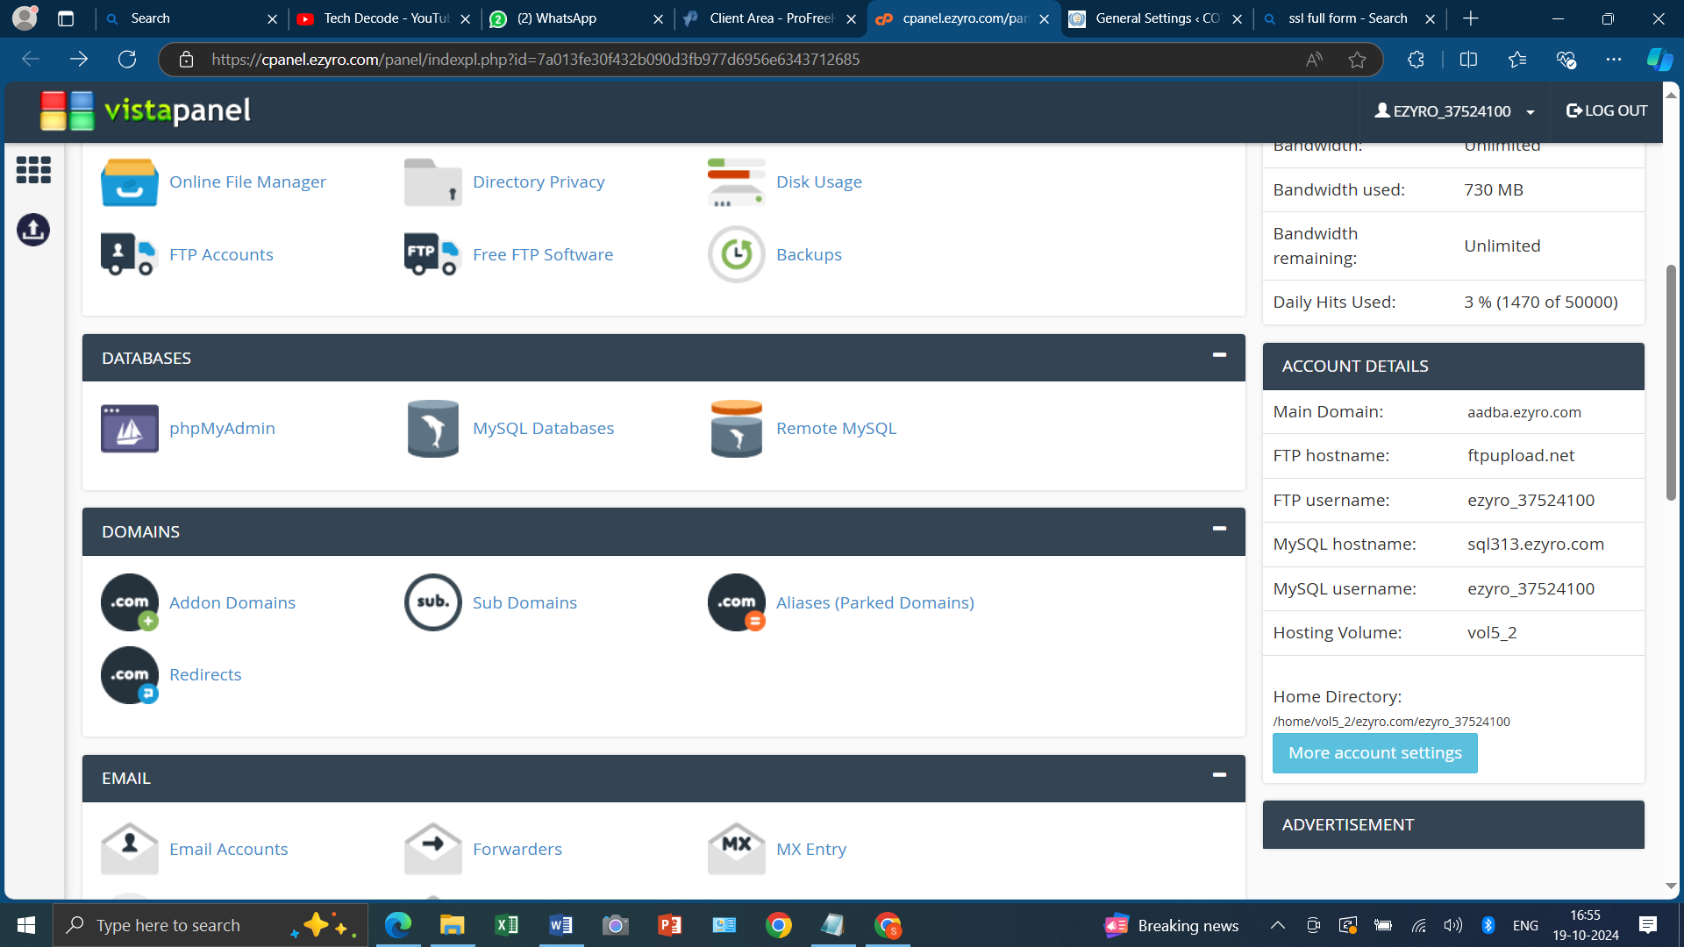
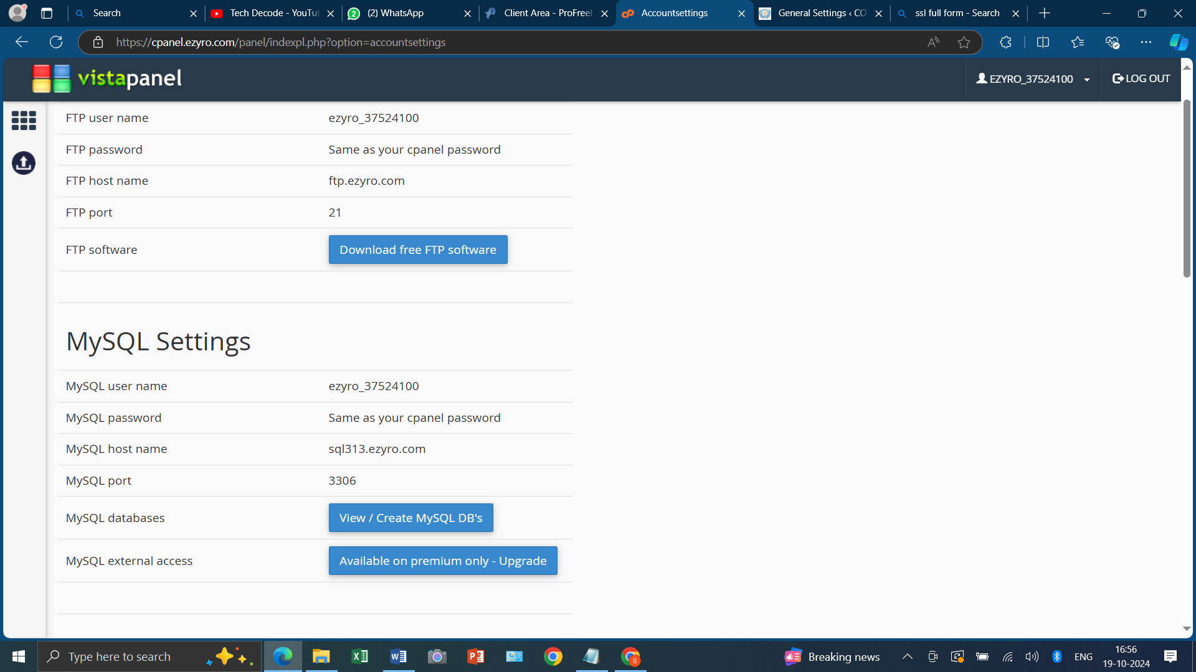
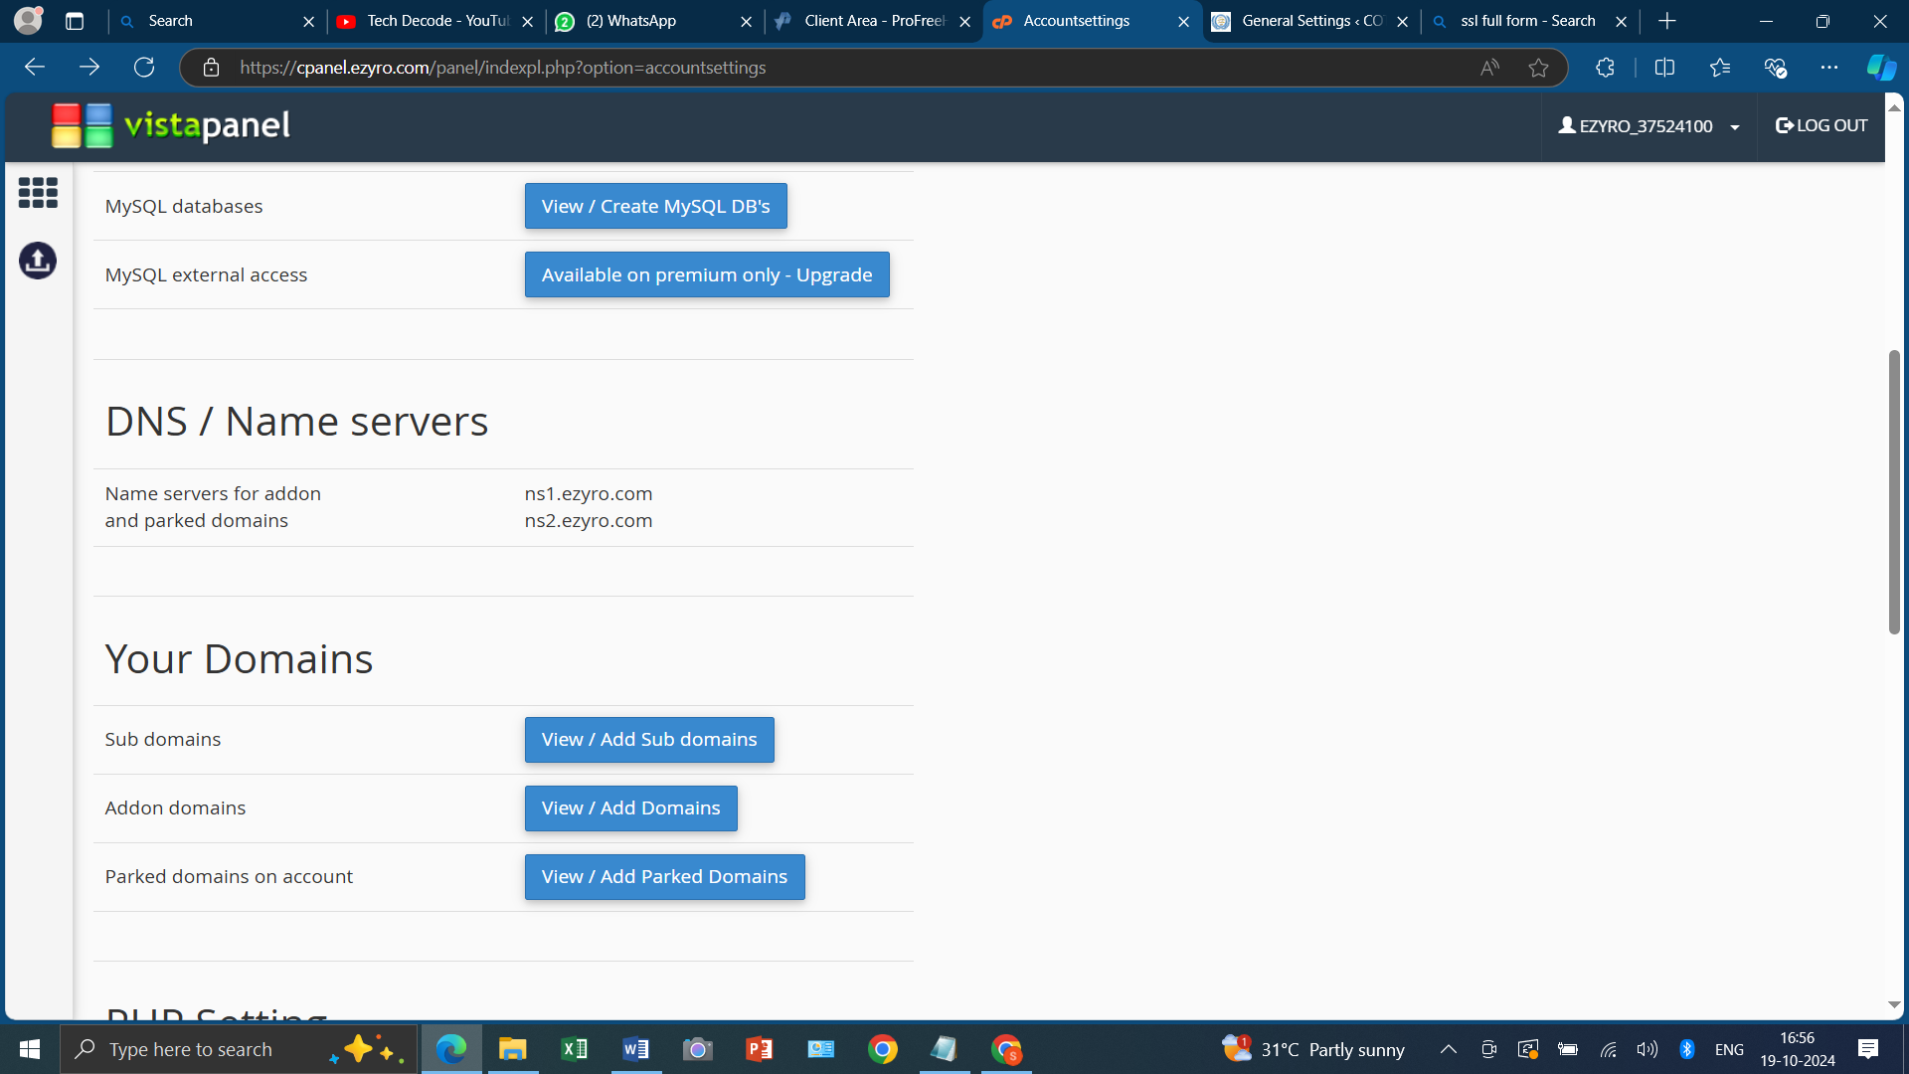

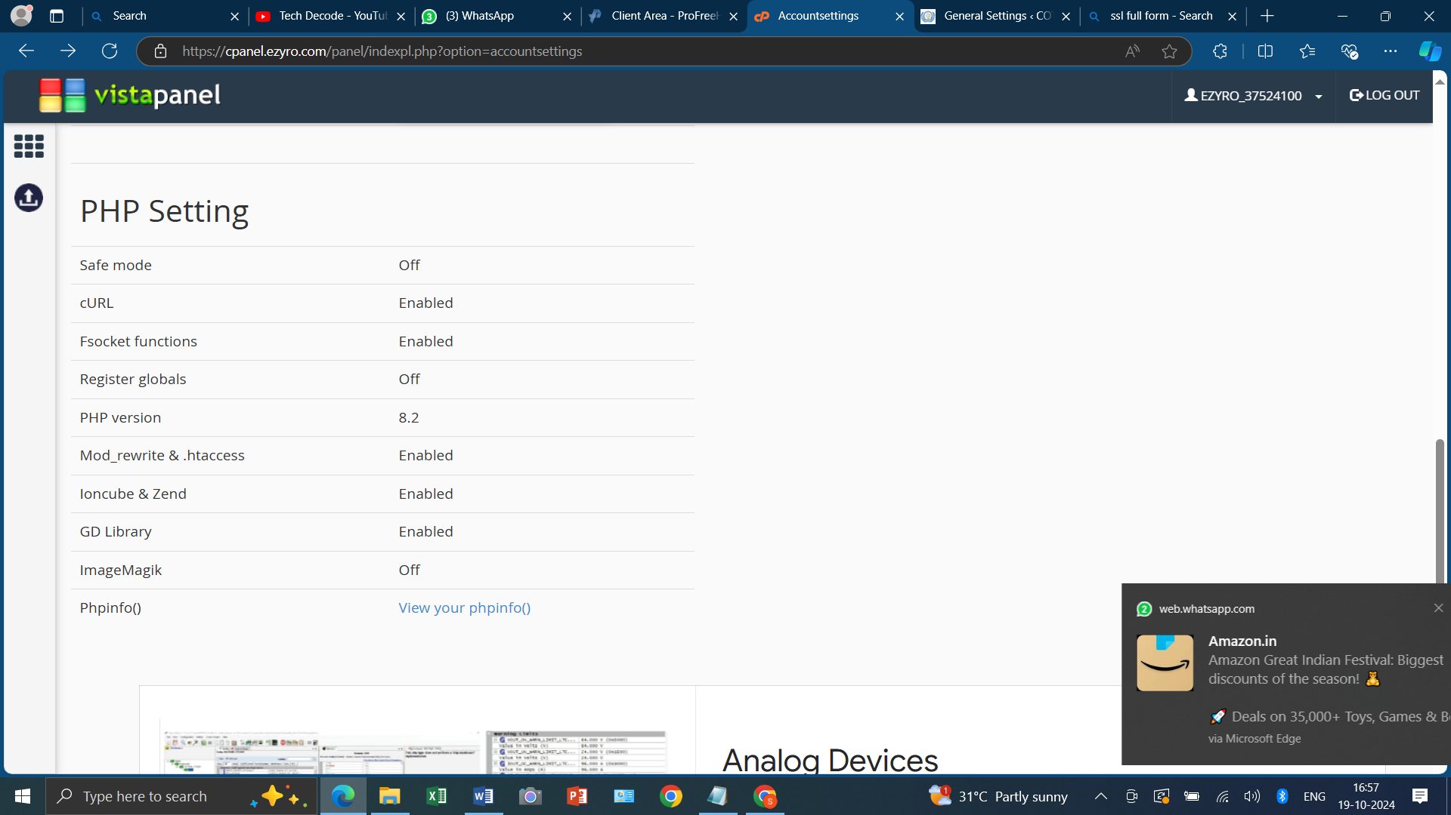
`AIRLIFT
iPpRHOWuJgYzSJMKxNezCGoHt1R2q0lE

